Master Functional Document

Application | NGERP - Centra
Service Bundle | Master Management
Service Request | Reporting Hierarchy

Description :

Reporting hierarchy is order in which the tree is arranged. A tree master is mapped with the reporting hirearchy.

Workflow Process :

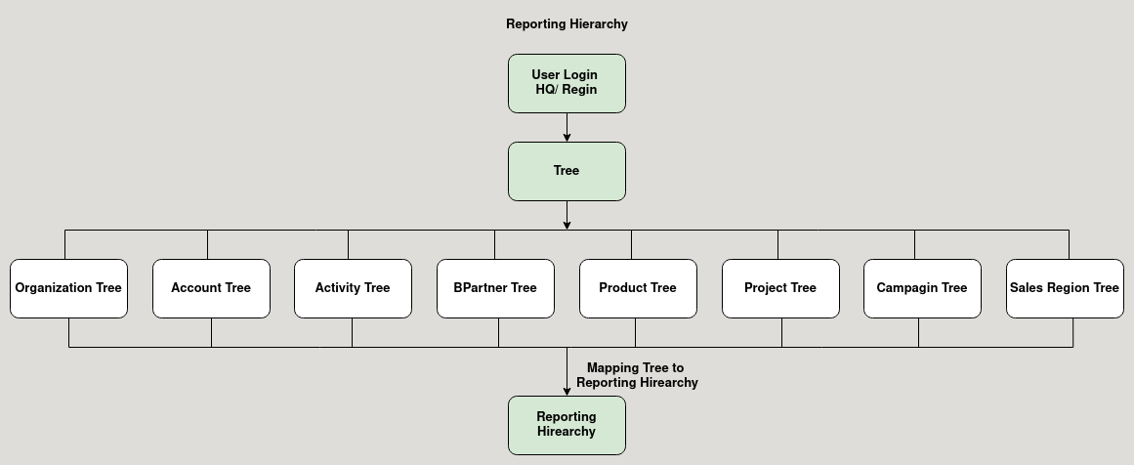

Business Rules :

- User can login as HQ or Region to create new Reporting Hirearchy.
- The below fields are mandatory to create Reporting Hirearchy
  - Organization Tree
  - Account Tree
  - Activity Tre
  - BPartner Tre
  - Product Tree
  - Project Tree
  - Campagin Tree
  - Sales Region Tree
- Tree master is mapped in the Report Hirearchy master

